./

Learning Report – Embedded C - Hardware + Programming + Testing

|  |  |  |  |  |  |
| --- | --- | --- | --- | --- | --- |
| **Ver. Rel. No.** | **Release Date** | **Prepared. By** | **Reviewed By** | **Approved By** | **Remarks/Revision Details** |
| 1.1 | 30-Sept-2020 | Anand A Warrier |  | Dr. Vivek Kaundal, Bhargav N | Initial draft report for review |
|  |  |  |  |  |  |
|  |  |  |  |  |  |
|  |  |  |  |  |  |
|  |  |  |  |  |  |

**Document History**

Contents

List of figures 4

Activity 1 – Writing linker scripts 5

Activity 2 – Semi Hosting technique 7

Activity 3 – In class activity 8

Activity 4 – Debugging techniques 10

Activity 5 – Completing MCU specific header files 15

# List of figures

Figure 1 - Linker script 5

Figure 2 - Semi hosting technique to print "Hello World" 6

Figure 3 - RCC bit enabled for SPI1 register 8

Figure 4 - SPE bit of SPI control register enabled 8

# Activity 1 – Writing linker scripts

**Requirement:** Create one memory location in the linker script.

**Code:**

//Entry point

ENTRY(Reset_Handler)

//Memories definition

MEMORY

{

FLASH(rx):ORIGIN =0x08000000,LENGTH =1024K

SRAM(rwx):ORIGIN =0x20000000,LENGTH =128K

}

//Sections

SECTIONS

{

.text :

{

*(.isr_vector)

*(.text)

*(.text.*)

*(.init)

*(.fini)

*(.rodata)

*(.rodata.*)

. = ALIGN(4);

_etext = .;

}> FLASH

_la_data = LOADADDR(.data);

.data :

{

_sdata = .;

*(.data)

*(.data.*)

. = ALIGN(4);

_edata = .;

}> SRAM AT> FLASH

.bss :

{

_sbss = .;

__bss_start__ = _sbss;

*(.bss)

*(.bss.*)

*(COMMON)

. = ALIGN(4);

_ebss = .;

__bss_end__ = _ebss;

. = ALIGN(4);

end = .;

__end__ = .;

}> SRAM

} //close_Sections

**Screenshot:**

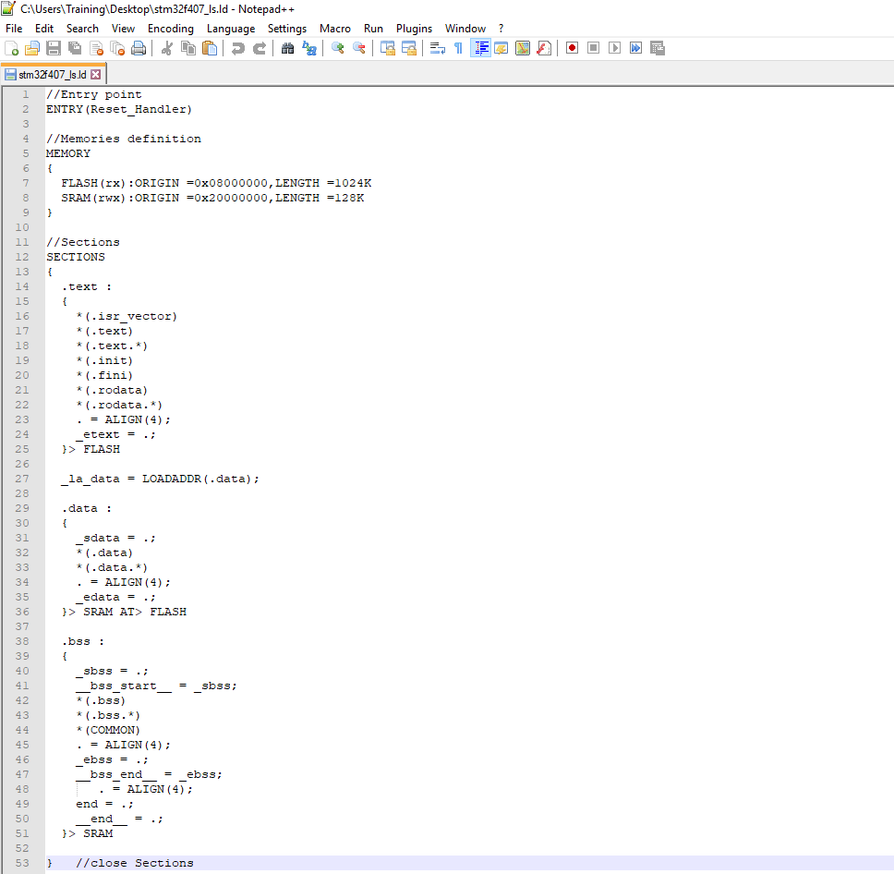

Figure 1 - Linker script

# Activity 2 – Semi Hosting technique

**Requirement:**

**Code:**

**#include** <stdio.h>

**extern** **void** **initialise_monitor_handles**(**void**);

**int** **main**(**void**)

{

initialise_monitor_handles();

**printf**("Hello World\n");

**for**(;;);

}

**Screenshot:**

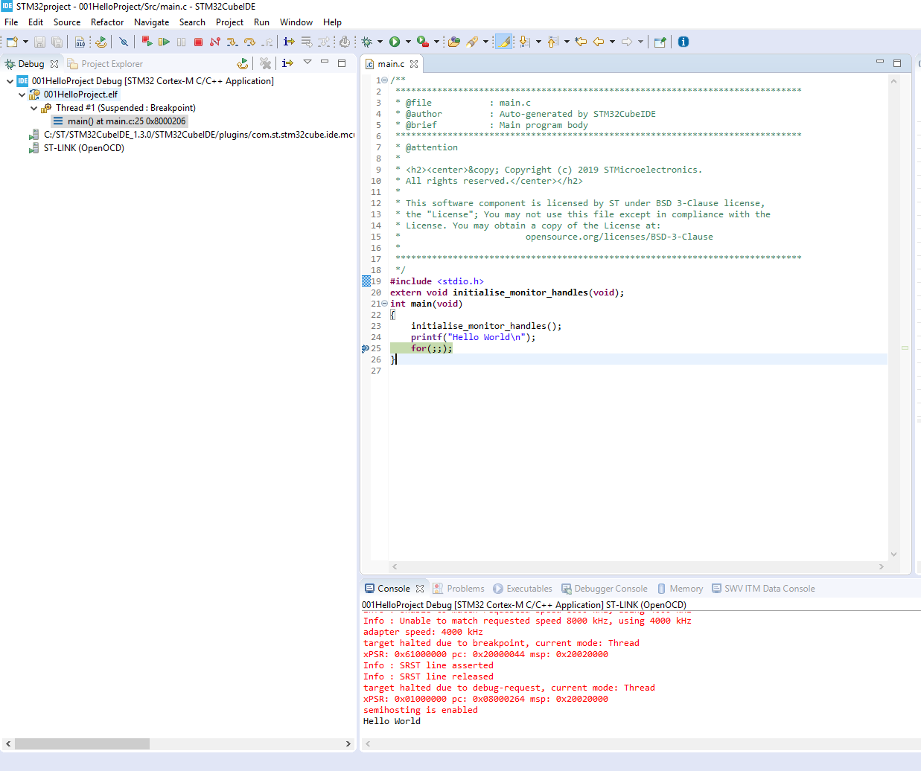

Figure 2 - Semi hosting technique to print "Hello World"

# Activity 3 – In class activity

**Requirement:** Enable SPE bit position of SPI control register 1 (SPI_CR1) by writing embedded C code.

**Code:**

**#include** <stdint.h>

**#define** SPI_BASE_ADDR 0x40013000UL

**#define** SPI_CR1_REG_OFFSET 0x00UL

**#define** SPI_CR1_REG_ADDR (SPI_BASE_ADDR + SPI_CR1_REG_OFFSET)

**#define** RCC_BASE_ADDR 0x40023800UL

**#define** RCC_APB2ENR_REG_OFFSET 0x44UL

**#define** RCC_APB2ENR_REG_ADDR (RCC_BASE_ADDR + RCC_APB2ENR_REG_OFFSET)

**int** **main**(**void**)

{

uint32_t *pSpiCr1Reg = (uint32_t*) SPI_CR1_REG_ADDR;

uint32_t *pRccApb2enrReg = (uint32_t*) RCC_APB2ENR_REG_ADDR;

*pRccApb2enrReg |= (1<<12); //enable the clock

*pSpiCr1Reg |= (1<<6); //set the 6th bit i.e SPE bit

/* Loop forever */

**for**(;;);

}

**Screenshot:**

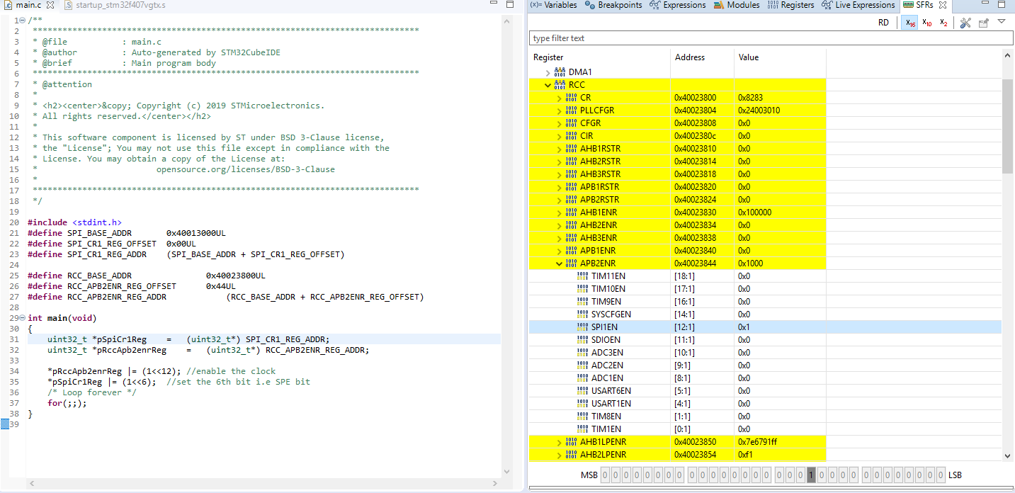

Figure 3 - RCC bit enabled for SPI1 register

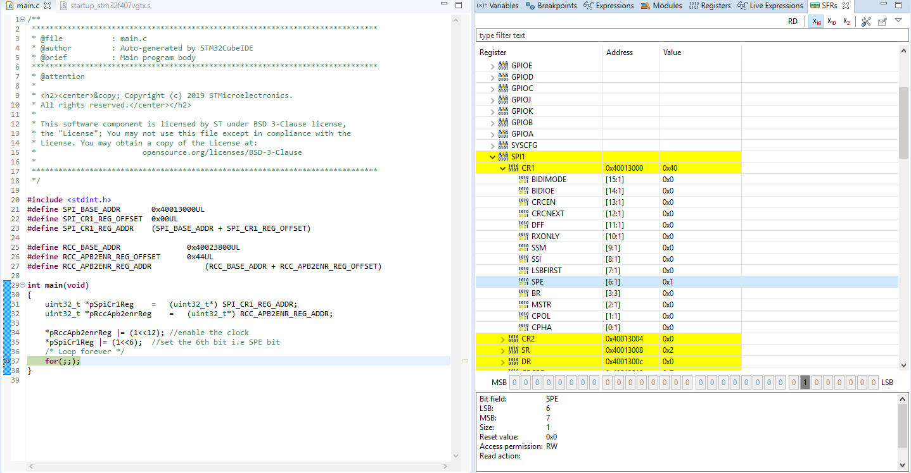

Figure 4 - SPE bit of SPI control register enabled

# Activity 4 – Debugging techniques

**Requirement:** Take any C code and try these debugging options :

* Serial wire viewer and data tracing (printf style debugging)
* Single stepping, stepping over and stepping out.
* Breakpoints (inserting, deleting and skipping breakpoints).
* Disassembly
* Call stack
* Expression and variable window
* Memory browser
* Data watch points

**Code:**

**main.c**

**#include** <stdio.h>

**int** **main**(**void**)

{

**printf**("Hello World\n");

**for**(;;);

}

**syscall.c**

**#include** <sys/stat.h>

**#include** <stdlib.h>

**#include** <errno.h>

**#include** <stdio.h>

**#include** <signal.h>

**#include** <time.h>

**#include** <sys/time.h>

**#include** <sys/times.h>

/////////////////////////////////////////////////////////////////////////////////////////////////////////

// Implementation of printf like feature using ARM Cortex M3/M4/ ITM functionality

// This function will not work for ARM Cortex M0/M0+

// If you are using Cortex M0, then you can use semihosting feature of openOCD

/////////////////////////////////////////////////////////////////////////////////////////////////////////

//Debug Exception and Monitor Control Register base address

**#define** DEMCR *((**volatile** uint32_t*) 0xE000EDFCU )

/* ITM register addresses */

**#define** ITM_STIMULUS_PORT0 *((**volatile** uint32_t*) 0xE0000000 )

**#define** ITM_TRACE_EN *((**volatile** uint32_t*) 0xE0000E00 )

**void** **ITM_SendChar**(uint8_t ch)

{

//Enable TRCENA

DEMCR |= ( 1 << 24);

//enable stimulus port 0

ITM_TRACE_EN |= ( 1 << 0);

// read FIFO status in bit [0]:

**while**(!(ITM_STIMULUS_PORT0 & 1));

//Write to ITM stimulus port0

ITM_STIMULUS_PORT0 = ch;

}

/* Variables */

//#undef errno

**extern** **int** errno;

**extern** **int** **__io_putchar**(**int** ch) **__attribute__**((weak));

**extern** **int** **__io_getchar**(**void**) **__attribute__**((weak));

**register** **char** * stack_ptr **asm**("sp");

**char** *__env[1] = { 0 };

**char** **environ = __env;

/* Functions */

**void** **initialise_monitor_handles**()

{

}

**int** **_getpid**(**void**)

{

**return** 1;

}

**int** **_kill**(**int** pid, **int** sig)

{

errno = EINVAL;

**return** -1;

}

**void** **_exit** (**int** status)

{

_kill(status, -1);

**while** (1) {} /* Make sure we hang here */

}

**__attribute__**((weak)) **int** **_read**(**int** file, **char** *ptr, **int** len)

{

**int** DataIdx;

**for** (DataIdx = 0; DataIdx < len; DataIdx++)

{

*ptr++ = __io_getchar();

}

**return** len;

}

**__attribute__**((weak)) **int** **_write**(**int** file, **char** *ptr, **int** len)

{

**int** DataIdx;

**for** (DataIdx = 0; DataIdx < len; DataIdx++)

{

//__io_putchar(*ptr++);

ITM_SendChar(*ptr++);

}

**return** len;

}

**int** **_close**(**int** file)

{

**return** -1;

}

**int** **_fstat**(**int** file, **struct** stat *st)

{

st->st_mode = S_IFCHR;

**return** 0;

}

**int** **_isatty**(**int** file)

{

**return** 1;

}

**int** **_lseek**(**int** file, **int** ptr, **int** dir)

{

**return** 0;

}

**int** **_open**(**char** *path, **int** flags, ...)

{

/* Pretend like we always fail */

**return** -1;

}

**int** **_wait**(**int** *status)

{

errno = ECHILD;

**return** -1;

}

**int** **_unlink**(**char** *name)

{

errno = ENOENT;

**return** -1;

}

**int** **_times**(**struct** tms *buf)

{

**return** -1;

}

**int** **_stat**(**char** *file, **struct** stat *st)

{

st->st_mode = S_IFCHR;

**return** 0;

}

**int** **_link**(**char** *old, **char** *new)

{

errno = EMLINK;

**return** -1;

}

**int** **_fork**(**void**)

{

errno = EAGAIN;

**return** -1;

}

**int** **_execve**(**char** *name, **char** **argv, **char** **env)

{

errno = ENOMEM;

**return** -1;

}

**Screenshot:**

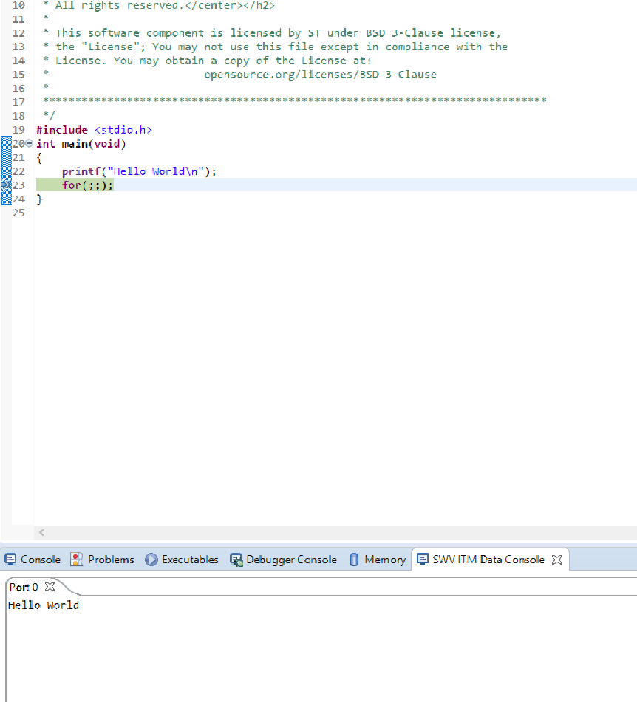

Figure 5 - Serial Wire Viewer

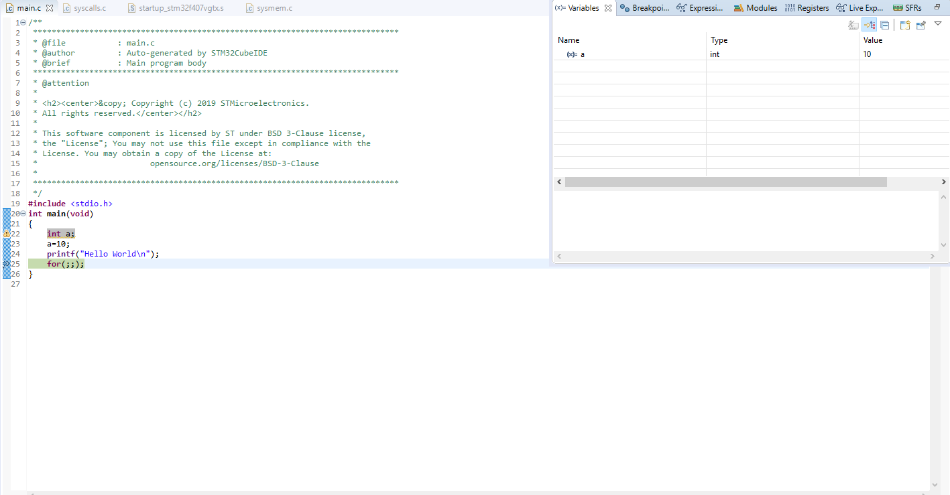

Figure 6 - Variable window

# Activity 5 – Completing MCU specific header files

**Requirement:**